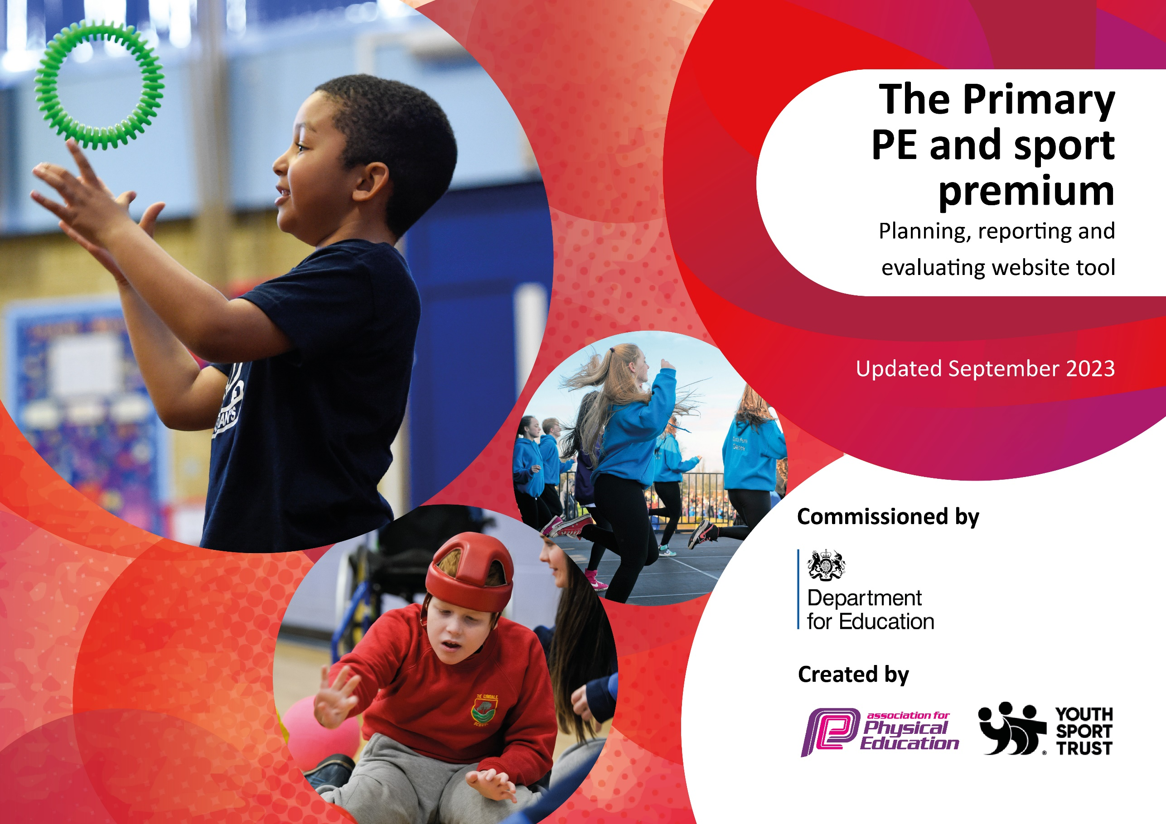

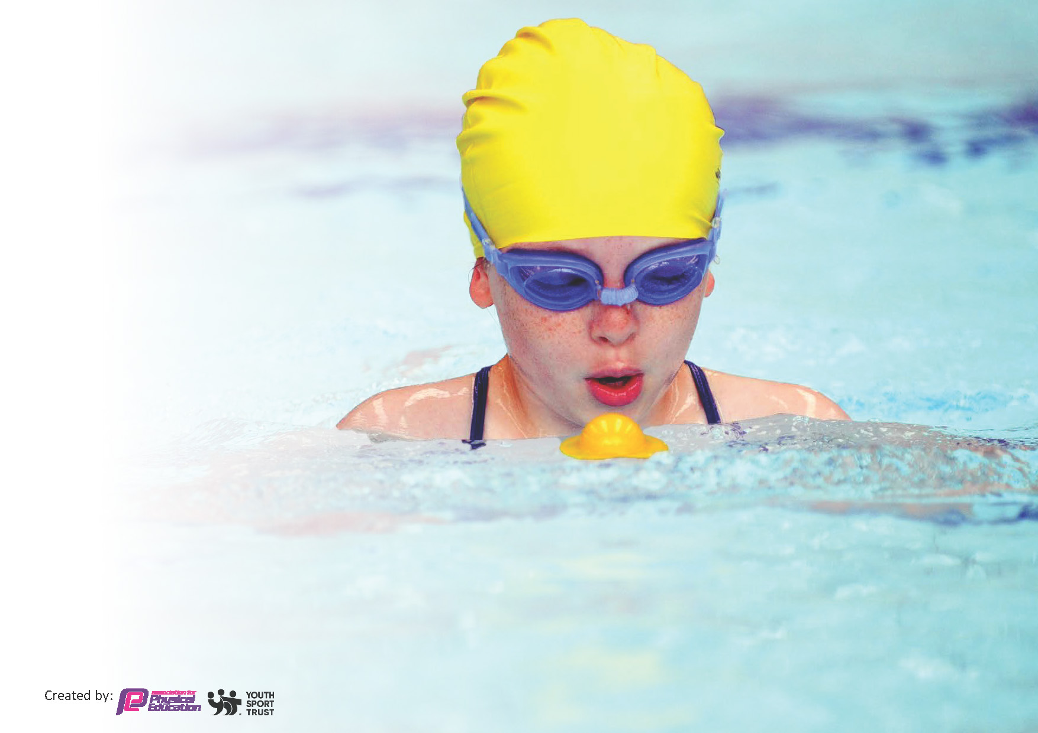
This template can be used for multiple purposes:
by:
- It enables schools to effectively plan their use of the Primary PE and sport premium
- It helps schools to meet the requirements (as set out in guidance) to publish information on their Primary PE and sport premium
- It will be an effective document to support Ofsted inspections enabling schools to evidence progress in Physical Education (PE) and evidence swimming attainment, which forms part of the PE National Curriculum. We would recommend schools consider
the Intent, Implementation and Impact of any spend, as examined within the Education Inspection Framework.

It is important that your grant is used effectively and based on school need.

Schools must use the funding to make additional and sustainable
improvements to the quality of the PE, School Sport and Physical Activity (PESSPA)
they offer. This means that you should use the Primary PE and sport premium to:

- Build capacity and capability within the school to ensure that improvements made now will benefit pupils joining the school in future years
- Develop or add to the PESSPA activities that your school already offers.

The Primary PE and sport premium should not be used to fund capital spend projects; the school’s core budget should fund these. Further detail on capital expenditure can be found in the updated Primary PE and sport premium guidance.

The Primary PE and sport premium guidance, outlines 5 key priorities that funding should be used towards. It is not

necessary that spending has to meet all the key priorities, you should select the priorities that you aim to use any funding towards.

Although completing this template is not a requirement for schools, schools are required to publish details of how they spend this funding. Schools must also outline what the impact this funding has had on pupils’ PE and sport participation and attainment and how any spending will be sustainable in the future. All funding must be spent by 31st July 2024.

The Department for Education has worked closely with the Association for Physical Education (afPE) and the Youth Sport Trust (YST) to develop this template and encourages schools to use it. This template is an effective way of meeting the reporting requirements of the Primary PE and sport premium.
Review of last year’s spend and key achievements (2022/2023)

We recommend you start by reflecting on the impact of current provision and reviewing your previous spend.

Activity/Action | Impact | Comments
See Evidencing the Impact of the PE and Sport Premium 2022-23 IMPACT document on Key Information on the school website.

Key priorities and Planning
This planning template will allow schools to accurately plan their spending.

Action – what are you planning to do | Who does this action impact? | Key indicator to meet | Impacts and how sustainability will be achieved? | Cost linked to the action
Create an all-weather outdoor pitch on the KS2 playground. | All pupils | Key indicator 1: The engagement of all pupils in regular physical activity – Chief Medical Officers guidelines recommend that primary school pupils undertake at least 30 minutes of physical activity a day in school | Pupils will have access to more purposeful space to take part in outdoor activities.  The pitch will benefit all pupils as they move into KS2. | £33,016.77
Develop the role of Sports Captains throughout the school. | All pupils | Key indicator 2: The profile of PESSPA being raised across the school as a tool for whole school improvement | Sports Captains will take responsibility for promoting physical activity and daily exercise. They will raise the profile of PE and sports to their peers. This in turn will engage and inspire more children to get involved. | £200
Embed the ‘real PE’ curriculum at Northway.  Monitor the impact of the intent and implementation of the new ‘real PE’ curriculum. | All pupils  Staff | Key indicator 3: Increased confidence, knowledge and skills of all staff in teaching PE and sport | All pupils will access a high quality curriculum building on their skills with clear progression. The clear teaching points and resources will support staff to deliver high quality PE lessons. This will increase engagement with pupils. | £300
Promote physically healthy life choices, focusing on pupil participation in extra-curricular clubs. | All pupils | Key indicator 4: Broader experience of a range of sports and activities offered to all pupils | Pupils will have access to a wider range of extra-curricular activities. This will expose them to different opportunities that they may not access outside of school. This will encourage a lifelong commitment to their health and physical activity. | £500
Participate in as many of the MADCOS PE events and competitions as possible throughout the year. | All pupils | Key indicator 5: Increased participation in competitive sport | This will extend the offer to what pupils can participate in. This will encourage opportunities for developing the competitive side of sports and developing good sportsmanship skills. It will also provide the opportunities to celebrate the achievements of pupils. | £500

Key achievements 2023-2024
This template will be completed at the end of the academic year and will showcase the key achievements schools have made with their Primary PE and sport premium spending.

Activity/Action | Impact | Comments
Create an all-weather outdoor pitch on the KS2 playground.  Develop the role of Sports Captains throughout the school.  Embed the ‘real PE’ curriculum at Northway.  Monitor the impact of the intent and implementation of the new ‘real PE’ curriculum.  Promote physically healthy life choices, focusing on pupil participation in extra-curricular clubs.  Participate in as many of the MADCOS PE events and competitions as possible throughout the year. | The all-weather outdoor pitch has been completed and all KS2 pupils have utilised it throughout the year, taking the opportunity to access a more purposeful space for outdoor activities, including at playtimes, lunchtimes, PE lessons and Daily Exercise sessions.  Sports Captains have taken responsibility for promoting physical activity and daily exercise throughout the school, raising the profile of PE and sports to their peers. Mr Wright held regular meetings with Sports Captains each term, discussing PE and sport at Northway.  All PE lessons followed the long-term plan for PE which was mapped out to include all of the ‘real PE’ units in the order they should be taught. This ensured skills progression throughout the year and throughout all of the year groups as pupils have accessed a high-quality curriculum building on their skills with clear progression. Vikki Roberts from ‘real PE’ came into school to complete training with a range of teaching staff on several days, ensuring that staff are implementing the new curriculum correctly. The clear teaching points and resources have supported staff to deliver high quality PE lessons, thus increasing engagement with pupils.  An extracurricular strategic map was mapped out for the year in order to ensure that pupils from all year groups had the opportunity to take part in a range of enrichment activities. Clubs included sports clubs, creative clubs and stem clubs and all teaching staff ran a club for at least one term. As teaching staff led the clubs rather than outside agencies, there was no charge for pupils to take part and there was a high rate of participation, with priority of places given to vulnerable and Pupil Premium pupils. Clubs included football club, running club, Art club, Lego club, choir, sewing club, gardening club, drama club and more. A ‘Health Week’ also took place in the summer term which involved the children completing a range of activities, including a sponsored ‘Sports For Schools’ fitness circuit with a GB Paralympic athlete. Pupils have had access to a wide range of extra-curricular activities which has exposed them to different opportunities that they may not access outside of school.  Children from different year groups have taken part in a wide range of MADCOS PE events throughout the year, including cross country races, futsal tournaments, swimming galas, multi-skills afternoons and fun runs. The boys’ football team and the girls’ football team have also played in lots of football matches, with the boys getting to the final of the MADCOS Supercup and the girls winning the MADCOS Supercup. All of the children who have taken part in these events have been celebrated in whole-school assemblies as well as in newsletters and on Twitter/X. The girls’ football team were also presented with their trophy at the MADCOS Sports Awards. | Steps for next year:  Continue to plan an enriched offer for pupils to develop a love of sports and access different extra-curricular clubs.  Focus on developing an enhanced offer for physical development in the Infants.  Develop the plan for daily exercise across the whole school.

Swimming Data for Y6 pupils who left in 2023
Meeting National Curriculum requirements for swimming and water safety.
Priority should always be given to ensuring that pupils can perform safe self-rescue even if they do not fully meet the first two requirements of the National Curriculum programme of study

Question | Stats: | Further context  Relative to local challenges
What percentage of your current Year 6 cohort can swim competently, confidently and proficiently over a distance of at least 25 metres? | 73% | The attendance of some vulnerable pupils means that this impeded on their ability to attend all sessions and complete their 25 metres successfully.
What percentage of your current Year 6 cohort can use a range of strokes effectively [for example, front crawl, backstroke, and breaststroke]? | 10m front and back only – 88%  25m front and back only – 65%  25m front back and breaststroke – 31% | As above

What percentage of your current Year 6 cohort are able to perform safe self-rescue in different water-based situations? | 92% | As above
If your schools swimming data is below national expectation, you can choose to use the Primary PE and sport premium to provide additional top-up sessions for those pupils that did not meet National Curriculum  requirements after the completion of core lessons. Have you done this? | No | N/A
Have you provided CPD to improve the knowledge and confidence of staff to be able to teach swimming and water safety? | No | Not required as staff feel confident to teach swimming and are supported by a swimming teacher at The Meadows.

Signed off by:

Head Teacher: | Kate McKenzie
Subject Leader or the individual responsible for the Primary PE and sport premium: | Tim Wright
Chair of Governors: | Nina Peters
Date: | 26.7.24

