Name:__________________________ Date:___________________
WALT: Understand what has been read
Answer the following questions about the story, ‘The Elves and the Shoemaker.
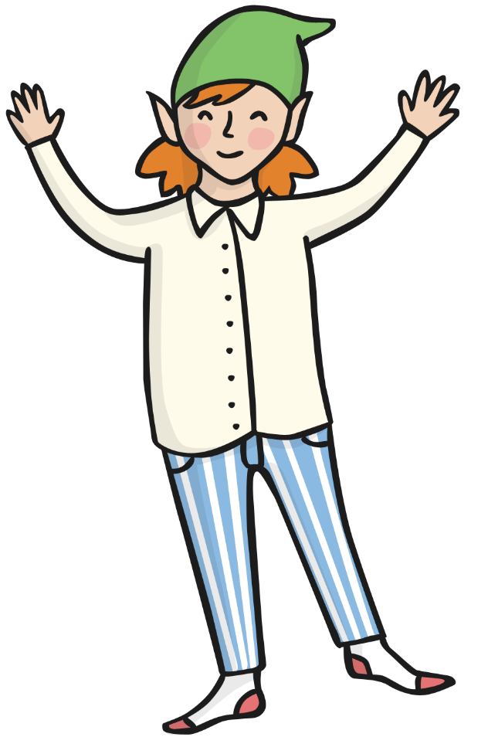
- Match the correct word to the picture.
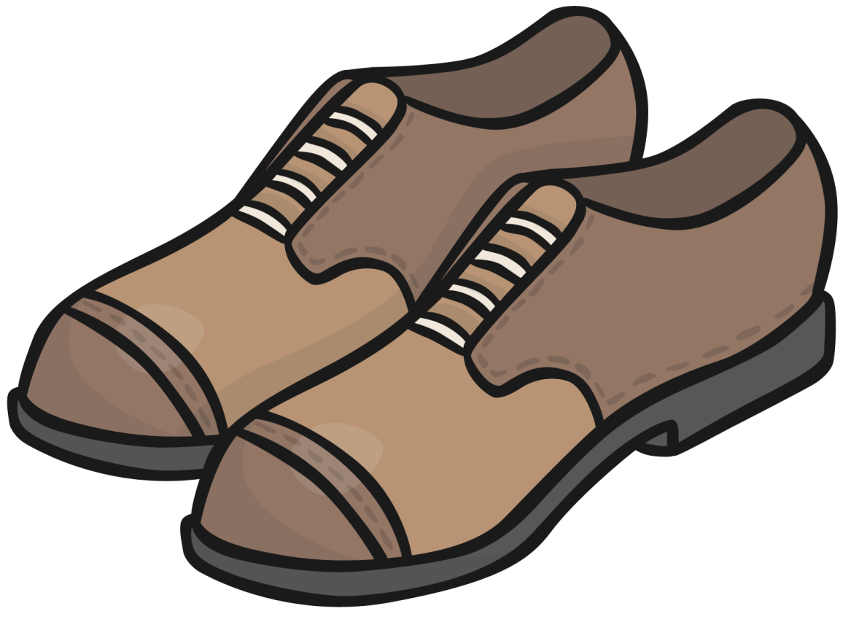

elf shoes

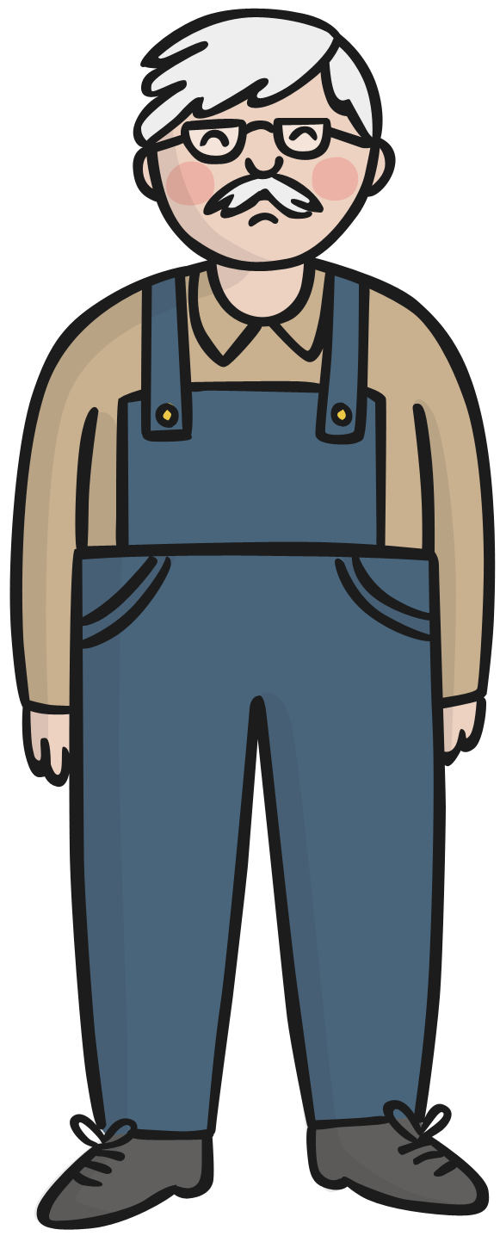
2. Tick the correct sentence to match the picture.
The shoemaker is sad. ___
The shoemaker is poor. ____
The shoemaker is cross. ____

3. Choose the correct word to complete the sentence.
The shoemaker cut out the last of his _ _ _ _ _ _ _
plastic | leather | fabric | cloth

4. Find and copy a word to describe the shoes.

He was amazed to find a beautiful pair of shoes standing on his table!

_____________________________________

5. What is the order in which the story happened?
Write 1, 2 or 3 under each sentence.
The shoemaker and his wife never saw the elves again. | The shoemaker woke up and saw that someone had made the shoes. | The shoemaker saw two small elves stitch the shoes together carefully.

6. Write yes or no for each sentence.
The elves were naughty. ___________
The shoemaker was scared of the elves. __________
The elves had no clothes at the beginning. _________

7. What did the shoemaker’s wife make for the elves? Tick the correct answer.
hat, scarf and gloves ______
shirts, trousers and socks ______
shirt, shoes and shorts ______

8. What was your favourite part of the story? Draw it in the box below.

