Name:__________________________ Date:___________________
WALT: Understand what has been read

Answer the following questions about the story, ‘The Elves and the Shoemaker’.

- Underline the two adjectives in the following two sentences from the story:
Once upon a time there lived a very poor shoemaker and his wife. Match the correct word to the picture.

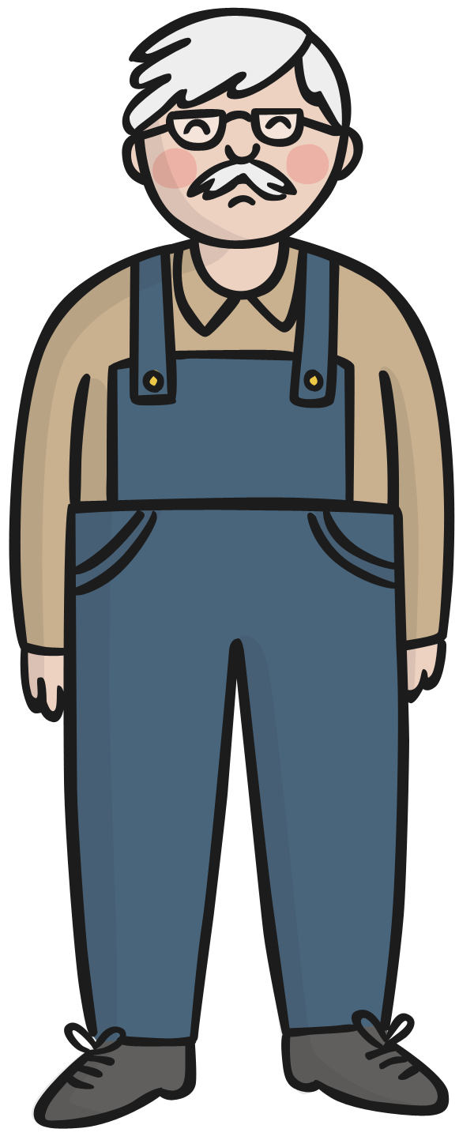
The next morning he was amazed to find a beautiful pair of shoes standing on his table!

2. Tick the correct sentence to match the picture.
At the start of the story, the shoemaker is rich. ___
At the start of the story, the shoemaker is poor. ___
At the start of the story, the shoemaker is happy. ___

3. Choose the correct word to complete the sentence.
The shoemaker cut out the last of his _ _ _ _ _ _ _
plastic | leather | fabric | cloth

4. What did the shoemaker and his wife do to try and find out who they owed their riches to?

______________________________________________________________________

______________________________________________________________________

5. Find and copy the word from the following sentence which means that the elves were happy when they found the clothes the shoemaker had made for them:
When the elves crept into the shop that night and saw the clothes, they were so overjoyed they danced and sang with delight.

6. What is the order in which the story happened?
Write 1, 2 or 3 under each sentence.
The shoemaker and his wife never saw the elves again. | The shoemaker woke up and saw that someone had made the shoes. | The shoemaker saw two small elves stitch the shoes together carefully.
7. Write true or false for each sentence.

The elves were naughty. __________________

The shoemaker was scared of the elves. __________________

The elves had no clothes at the beginning. __________________

8. What did the shoemaker’s wife make for the elves? Tick the correct answer.
hat, scarf and gloves ______
shirts, trousers and socks ______
shirt, shoes and shorts ______

9. Re-read the last line of the story again:
The shoemaker and his wife never saw the elves again but they were forever grateful to them for showing them how to make beautiful shoes.

List five other adjectives which the author could have used instead of beautiful:

___________________________

___________________________

___________________________

___________________________

___________________________

10. What was your favourite part of the story? Draw it in the box below.

