Name:________________________ Date:__________________________________
WALT: Understand a text

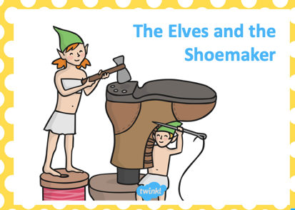
In this lesson, we are going to show our understanding of the story. ‘The Elves and the Shoemaker’. Before you read the story complete the prediction part of the work sheet.

Prediction

Using the title and the pictures, predict what you think this story will be about.

_______________________________________________________________________

_______________________________________________________________________

_______________________________________________________________________

Clarification

Where there any words you didn’t understand? Look them up and write down what they mean.

Word | Meaning
__________________ | __________________________________________________
__________________ | __________________________________________________
__________________ | __________________________________________________
__________________ | __________________________________________________

Summarise

Can you tell me what happened in the story using only one or two sentences?

_______________________________________________________________________

_______________________________________________________________________

_______________________________________________________________________

_______________________________________________________________________

