Name:______________________ Date:__________________
WALT: Describe the difference between deciduous trees and evergreen trees

In this lesson, we learnt about the difference between deciduous trees and evergreen trees. Complete the following sentences.

A deciduous tree_________________________________________________________

______________________________________________________________________

An evergreen tree________________________________________________________

______________________________________________________________________

Draw and colour how a deciduous tree might look through these seasons.
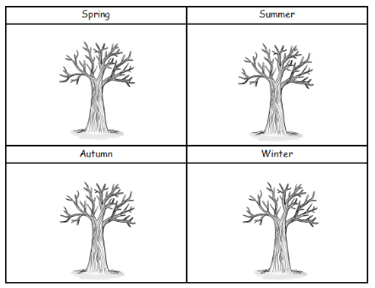

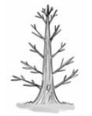
Draw and colour how an evergreen tree might look in all seasons.

